Yuyi Zhang
Oct 11, 2020
Fall 2020 CPS Quarter
Instructor: Dr. Steward Huang
Module 4:
Random Forests
ALY 6020_Predictive Analytics

Introduction
In this report, we are going to go through two datasets using Random Forests algorithm. The random forests are made out of decision trees. It combines the simplistic of decision trees with flexibility resulting in vast improvement in accuracy. For the practices, the first dataset is Glass Identification Data Set. The second one is South German Credit, that I have used in the first week.

Analysis

Glass Identification Data Set

Step 1 – collecting data
Glass Identification Data Set contains 214 observations of 10 variables. There are 9 different features of glass and the target feature would be the type of glass. In this report, there are 7 different type of glasses. To study the classification of types of glass will be very useful for criminological investigation. In other words, this would turn the glass left in crime scene into evidence.

Step 2 – exploring and preparing the data
Importing data to R and take a look at the structure.
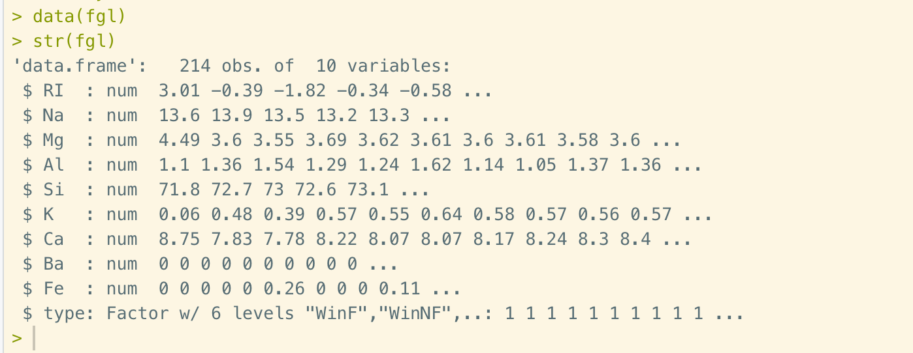
Figure 1. Importing data and structure
As we can see from the structure of data fgl, all the features are in the forms of number, and the target feature is in factor. This dataset is well formalized.

Step 3 – training a model on the data
In this step, we are going to use randomForest() function to train the model. The function is shown as below:
﻿randomForest(﻿formula, data=NULL, ntree=500,
mtry=if (!is.null(y) && !is.factor(y))
importance=FALSE, do.trace=FALSE)
We are going to use all of the 9 variables to train the model. The number of trees is going to remain in 500. The number variables for each internal node is set to 2 rather than default setting of the square root of the number of variables. The importance function is true. Lastly, set the trace of each evaluation to 100 trees.
Since we are going to be randomly sampling data, we need to set the seed for the random number generator so that we can reproduce our results. Then we could build the forest using following function.
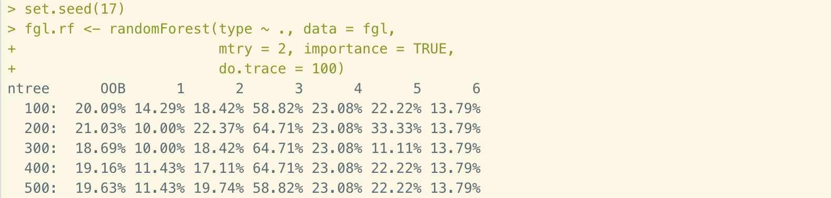
Figure 2. Employ Random Forest model to data
After each iteration, rondomForest() prints out the Out-of-Bag(OOB) error rate. It gets smaller indicating that the estimation is improving. And the OOB are not descending in the trees of 400 and 500, it means that the estimates are as good as they are going to get with this method.

Step 4 – evaluating model performance
To evaluate the performance of the model, simply use print() function to get a confusion matrix shown as below:
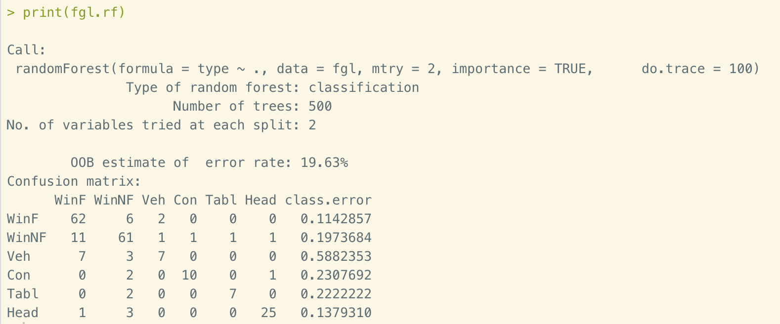
Figure 2. Employ Random Forest model to data
The OOB error estimate of this model is 19.63%. It means that 80.37% of the OOB samples were correctly classified by the random forest. In the confusion matrix we could see that there are 62+61+7+10+7+25 = 172 observations out of 214 are correctly classified. The lowest error rate is 11.4% for WinF. The highest error rate is 58.8% for Veh.

Step 5 – improving model performance
In this step, we are going to compare the Random forest with support vector machines (SVM) by 10 times 10-fold cross-validation. K-fold cross validation is a technique to evaluate predictive models such as Random forest. It is used by partitioning the original sample into a training set and test set. But in our case, since the samples are randomly generated, there won’t be repeating samples anyway. So, we don’t need to split our dataset into training data and test data. Below is the comparison of two models.
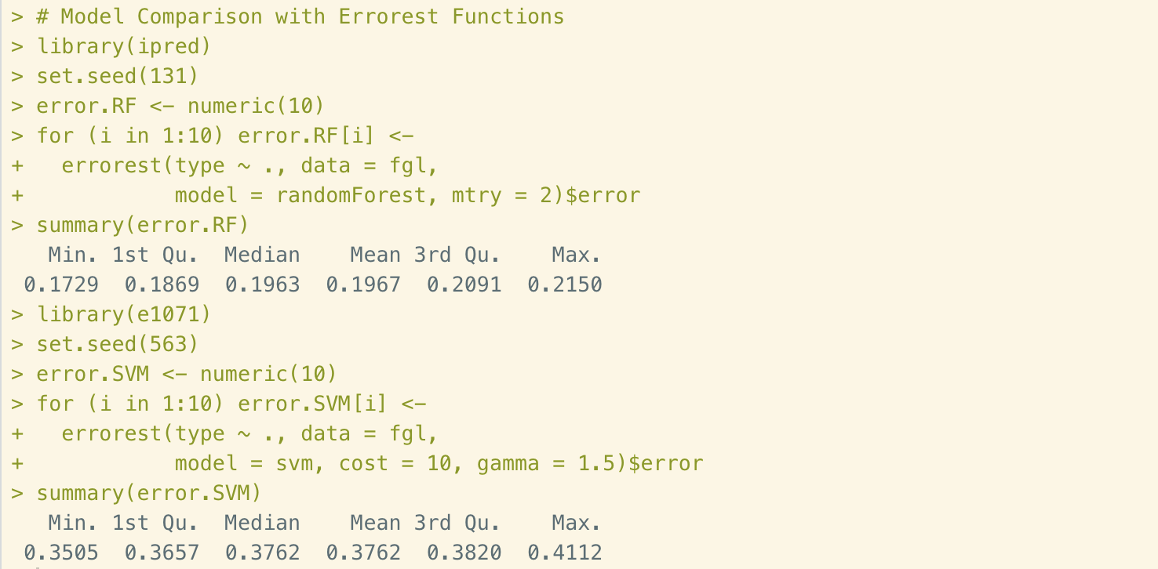
Figure 3. Model comparison
From the summaries we could see that Random forest returns much lower error rate than SVM. Therefore, the random forest compares favorably with SVM.
Next we are going to create variable importance of the dataset to compare 9 variables. This measure could be useful for model reduction.
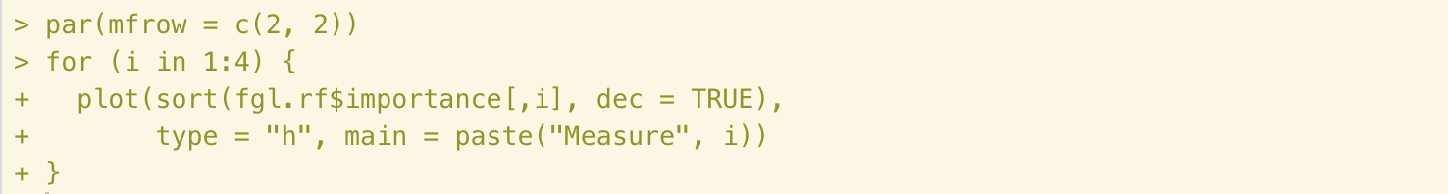
Figure 4. Coding importance of features
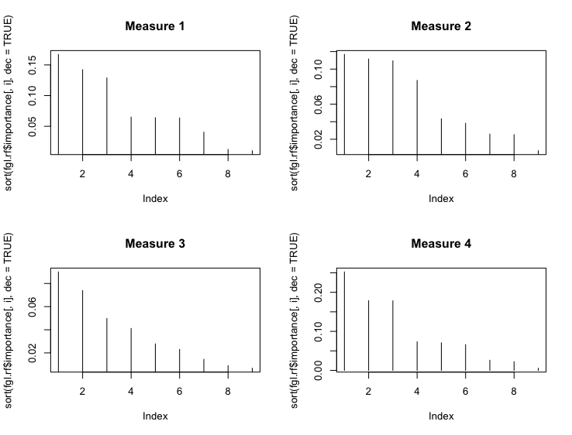
Figure 5. Variables importance comparison
From these four charts we could see that there are 3 features would affect the error rate the most.

South German Credit Data Set

Step 1 – collecting data
In Part II, we are going to go through the dataset that we’ve done in module 1 for the decision trees: South German Credit Data Set. We will again try to identify the default type for applicants by provided variables.

Step 2 – exploring and preparing the data
Import data to R, and take a look at the first few rows using head() function.
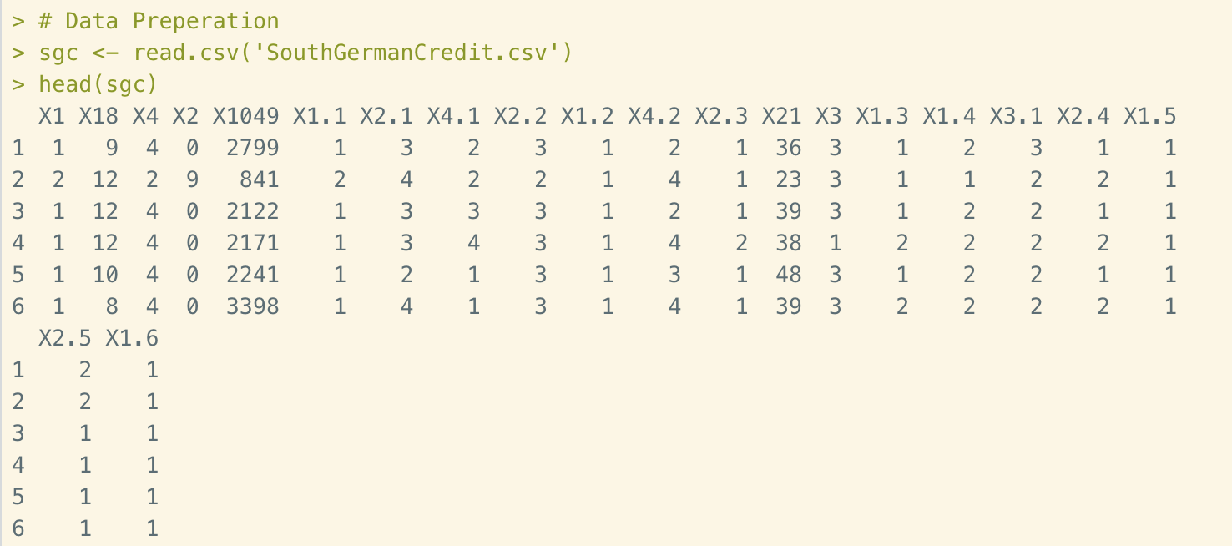
Figure 6. Importing data
In this dataset, there are 999 observations of 21 variables. As we could see, none of the columns are labeled. So we name the columns after the names that were listed by dataset code table text file.
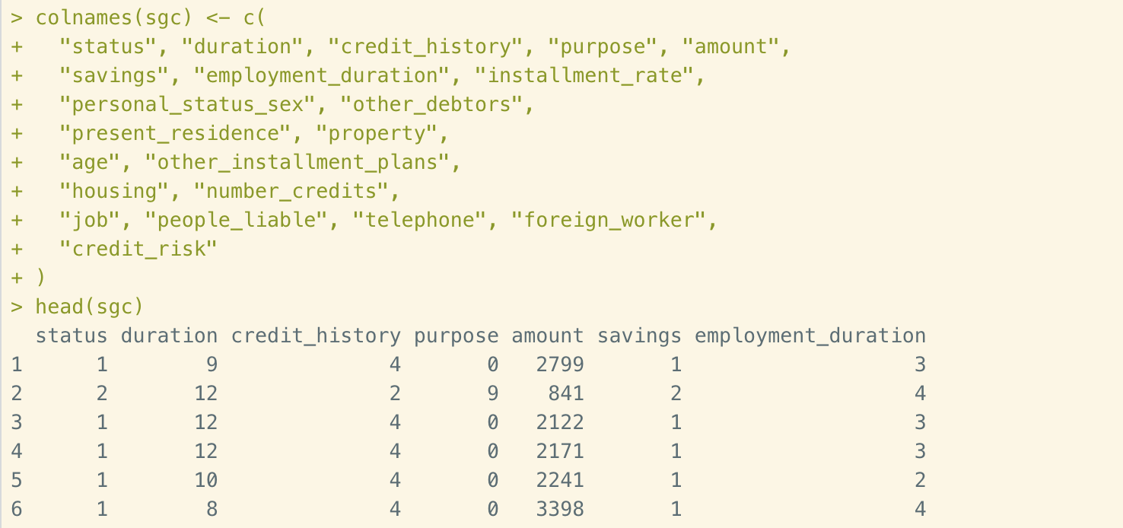
Figure 7. Name columns
Then we take a look at the structure of the data.
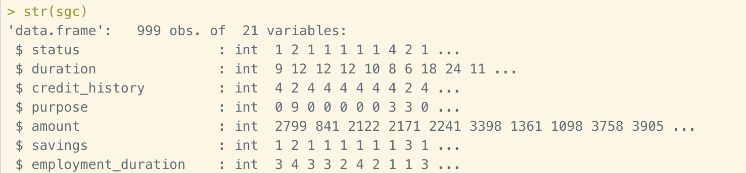
Figure 8. Data structure
As we could see that all the values are integers which are not easy to understand. So we label them regarding the guidance from code table text file. We will also convert the last column from “0” and “1” to “bad” and “good”. Then we convert a bunch of columns with labels. Below are partial code and top lines of the dataset structure.
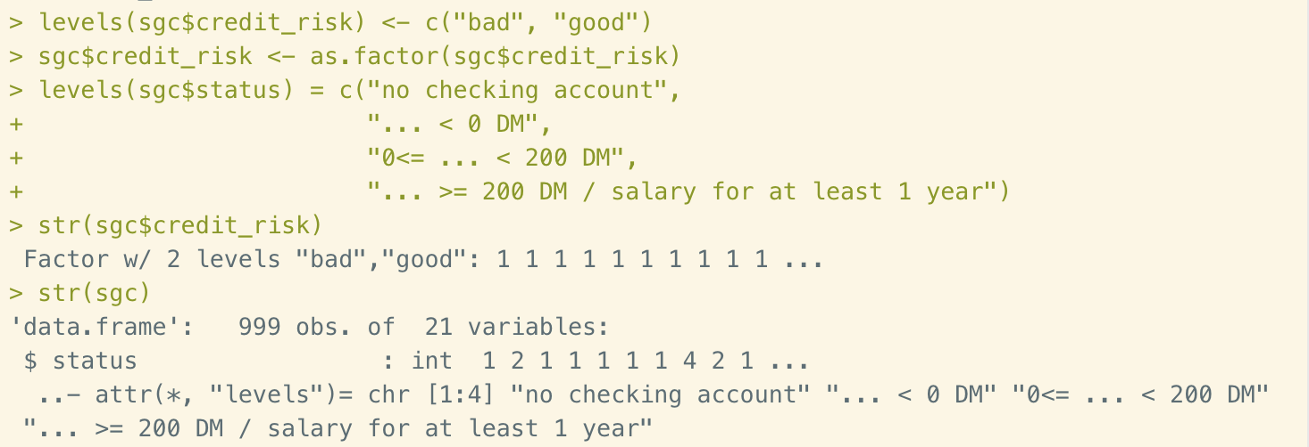
Figure 9. Label columns

Step 3 – training a model on the data
Now we are ready to build the Random forest model.
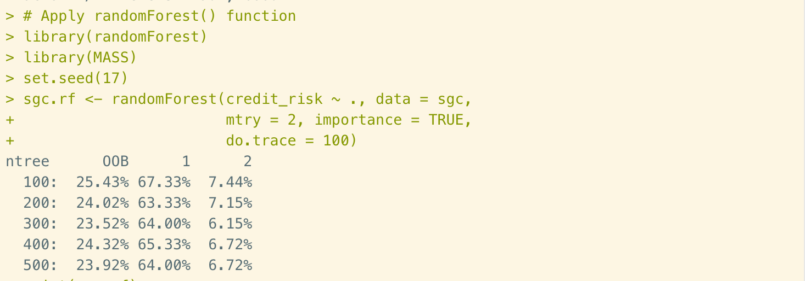
Figure 10. Build Random forest model
In this model, we used all of the variables except the last column of Credit Risk as our target variable. After each iteration, the OOB error rate remains at about 24%, which means the estimations are at the optimized level already.

Step 4 – evaluating model performance
To evaluate the performance of the model, we are going to print the result of the Random forest model, shown as below.
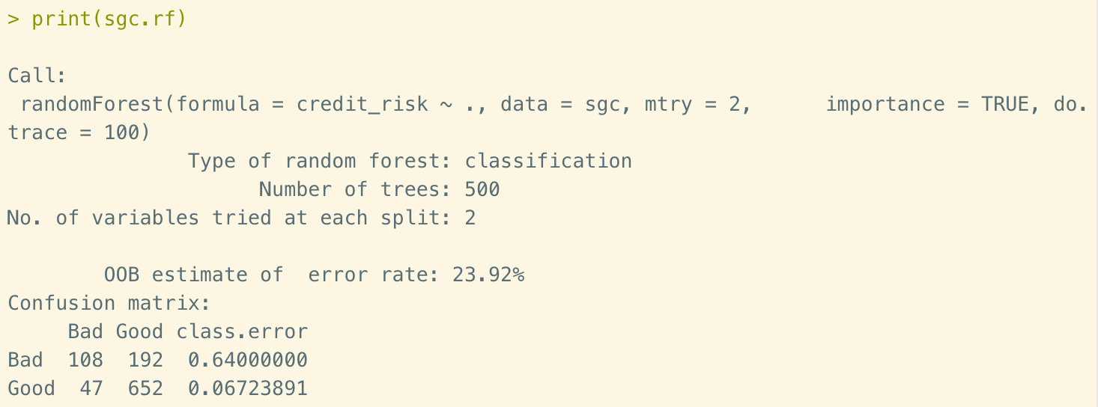
Figure 11. Model results
In this result we could see that the OOB error rate is 23.92%. The correct rate of “good credit” is 93.3%, which is very impressive. But the correct rate of “bad credit” is 36%.

Step 5 – improving model performance
In this step, we again, are going to compare the RF error rate with SVM 10 times 10-fold cross-validation, shown as below.
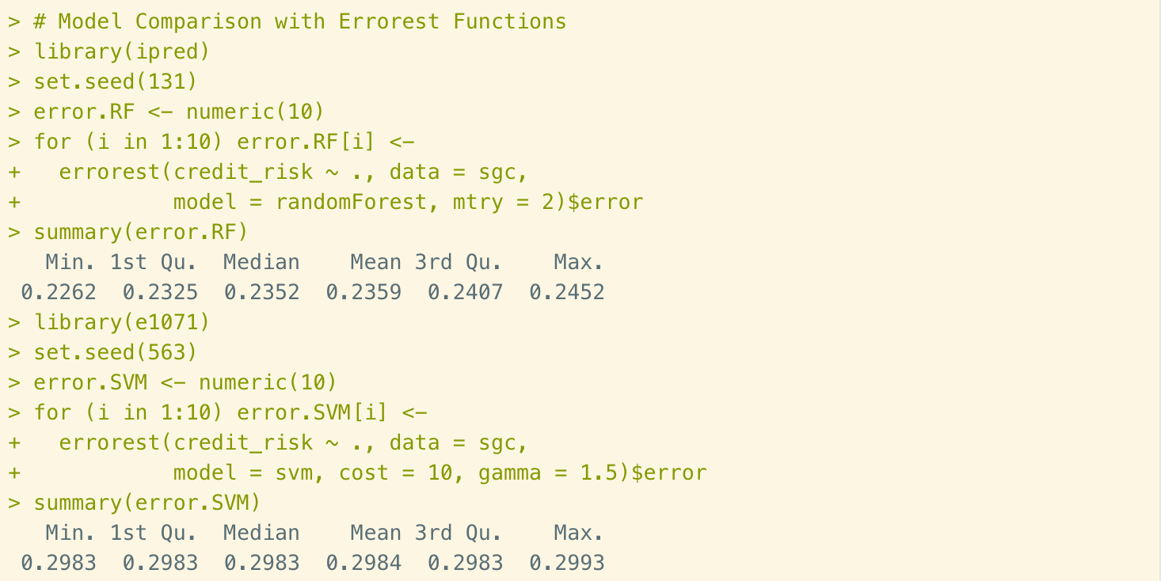
Figure 12. Model comparison
From the summaries of both model we could see that Random forest model returns lower minimum, maximum and other values than SVM. This means that random forest compares favorably with SVM.
Now let’s find out the importance of variables of the random forest model.
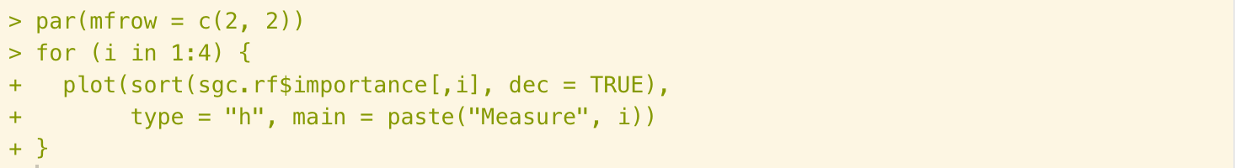
Figure 13. Variables importance coding
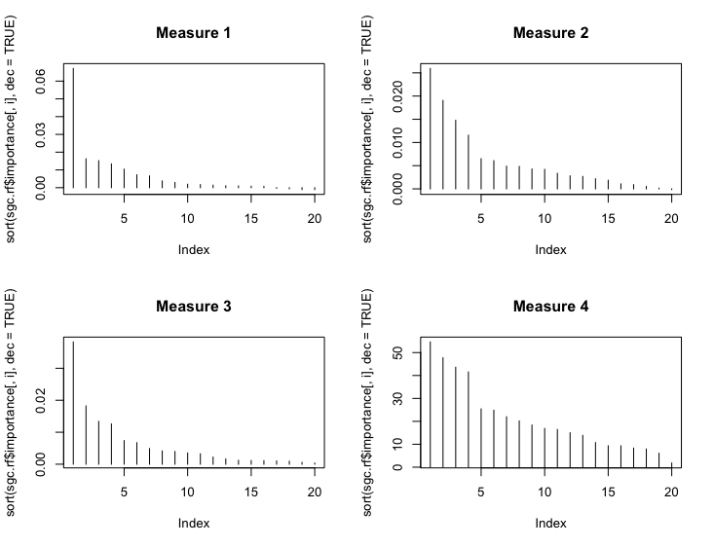
Figure 14. Variables importance
From measure 1 and 3 we could see that the first variable is provide the most effective of the classification. From measure 2 and 4, the first four variables showing more important role than others.

Conclusions
In this report, we practiced Random forest model in two different data set. The first data set was Forensic Science service of glass identification. We used 9 variables to classify glasses whether it was a type of “float” glass or not. After employing Random forest function, we’ve got a model with accuracy rate of 80.37%. The second data set was German credit data. We used 19 variables to classify whether the applicant attributes as good or bad credit risks. We’ve practiced this dataset earlier in module 1 for the K-mean Nearest Neighbor and a similar dataset in module 3 for the Decision Trees. The accuracy rate in module 1 was 73% by k-NN and was 77% in module 3 by Decision Trees. It was 76.18% in this report by Random forest. But the false negative rate was as high as 64%.

Reference
- Strickland J. (July 2015). Chapter 7: Random forests. In Predictive Analytics using R (pp. 109-121). Colorado Springs, CO: Simulation Educators.
- Machine Learning Repository. (1987, September 01). Glass Identification Data Set [Data file]. Retrieved from https://archive.ics.uci.edu/ml/datasets/glass+identification.
- Machine Learning Repository. (2020, June 20). South German Credit (UPDATE) Data Set [Data file]. Retrieved from https://archive.ics.uci.edu/ml/datasets/statlog+(german+credit+data).

